Python File Handling Assignment - Section 2

Task 1: Create and Write Student Data

CODE:
with open("StudentGradeManager.txt","w") as contxtMngr:
print("---------------TASK-1---------------------")
contxtMngr.write("Alice,85\nBob,92\nCharlie,78\nDiana,95")
print("Data saved successfully")

OUTPUT:
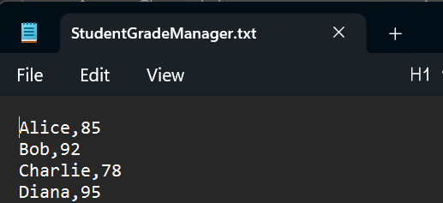

EXPLANATION:
I have used the write mode to create a file(if not present) and save the data inside the file. Used the with keyword because this will automatically handle the opening and closing of the file.

Task 2: Read and Display Data (Basic)
CODE:
try:
with open("StudentGradeManager.txt","r") as contxtMngr:
print("---------------TASK-2---------------------")
for line in contxtMngr:
Name,score = line.split(",")
print(f"Student: {Name}, Score: {score}")
except FileNotFoundError:
print("File is not found")
OUTPUT:
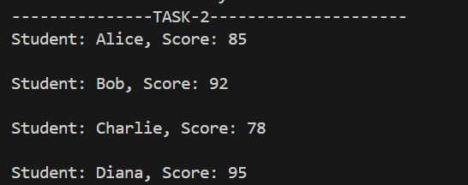
EXPLANATION:
I have used the “r”(read) mode to read the contents of the file. Using a for loop traversed trough each line present in the file. Splitting the line with “,” since the name and score are separated by “,”. Saving the name and score in the variables and printing it in the desired format.
Task 3: Append New Student and Create Log
CODE:
def logging(studentname):
with open("activity.log","a") as contxtMngr:
contxtMngr.write(f"Added new studed: {studentname}")
print("Entry logged successfully")

with open("StudentGradeManager.txt","a") as contxtMngr:
print("---------------TASK-3&4---------------------")
contxtMngr.write( "\nEve,88")
print("New entry added into the file successfully")
logging("Eve")
OUTPUT:
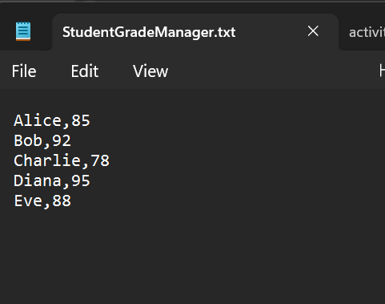
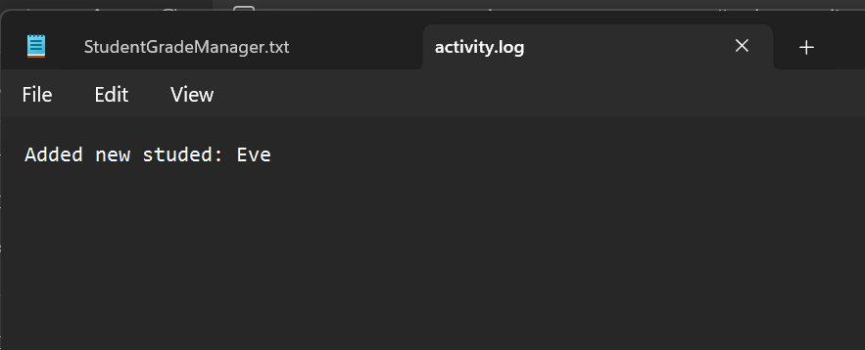
EXPLANATION:
Added a new entry in the file by opening it in “a”(append) mode, because it will not overwrite the existing contents of the file but append the data to the file at the end. Created a user-defined function called logging to log the entry activity into the file. This method has a parameter, “Name” which can be used to send the name of the entry added in the file.

